report on

“SOFTWARE rEQUIREMENTS dOCUMENT AND tECHNICAL dESIGN”

Submitted to:

**Dr Grace U. Nneji**

**Student ID: 202118010418**

**Group: L4-C3**

A coursework submitted in partial fulfillment of the requirements for the module of

[Information System]

­

OBU COMPUTING

Sino-British Collaborative Education

Date: 2023/5/20

Table of Contents

1. Software Requirements and technical design 3

1.1 Purpose of the project 3

1.1a Key features of the Proposed System 3

1.1b Main Stakeholders and their likely benefits 3

1.2 Scope of the project 5

1.3 Product perspective 7

1.4 Specific Requirements 9

2. Technical Design 26

2.1 Date Model 26

2.2 Sequence Diagrams 27

2.3 Analyzing the Date 34

Conclusion 36

References 37

1. **Software Requirements Document**

**1.1 Purpose of the project**

**1.1a Key features of the Proposed System**

The proposed system is a computerized information system designed for the Glamorous Hotel and Suite, which aims to replace the original manual system of the hotel and assist the manager in managing the hotel. The key features of the proposed system include room reservation management, customer record management, food ordering and delivery management, online payment, and reporting and analysis. The system will enable customers to book rooms online, maintain a database of customer records, facilitate food ordering and delivery, provide secure online payments, and provide daily transaction reports, customer details and food order analysis to support decision making.

**1.1b Main stakeholders of the proposed system and their likely benefits**

**i Stakeholder Name:** Customer/Walk-in guest

**Mention the benefits**

* Faster and more efficient room booking process.
* Safer and more convenient online payment.
* More accurate and secure record of personal information.
* More convenient and quick food ordering service.

**ii Stakeholder Name:** Manager

**Mention the benefits**

* Accurate and prompt reporting on transactions, providing valuable insights and data for informed decision-making.
* Efficient and streamlined customer record management that allows quick access to personal information.

**iii Stakeholder Name:** Front desk officer

**Mention the benefits**

* Manual workload is reduced, accuracy and work efficiency are improved.
* Automatically updates customer room bookings and cancellations, reducing the risk of errors and miscommunication.

**iv Stakeholder Name:** Cook

**Mention the benefits**

* Improved food ordering system that would make it easier to receive and process orders, reducing errors and miscommunications.
* Automated records of the menu ordered daily and the most ordered meal, allowing for better tracking of inventory and menu planning.

**v Stakeholder Name:** Waitress

**Mention the benefits**

* Ensure the accuracy and speed of work tasks, improve work efficiency.

**vi Stakeholder Name:** Bank

**Mention the benefits**

* More secure and efficient online payment functions streamline the payment process and reduce the risk of financial errors or disputes.

**1.2 Scope of the product**

**Dataflow Context Diagram (Level 0)**

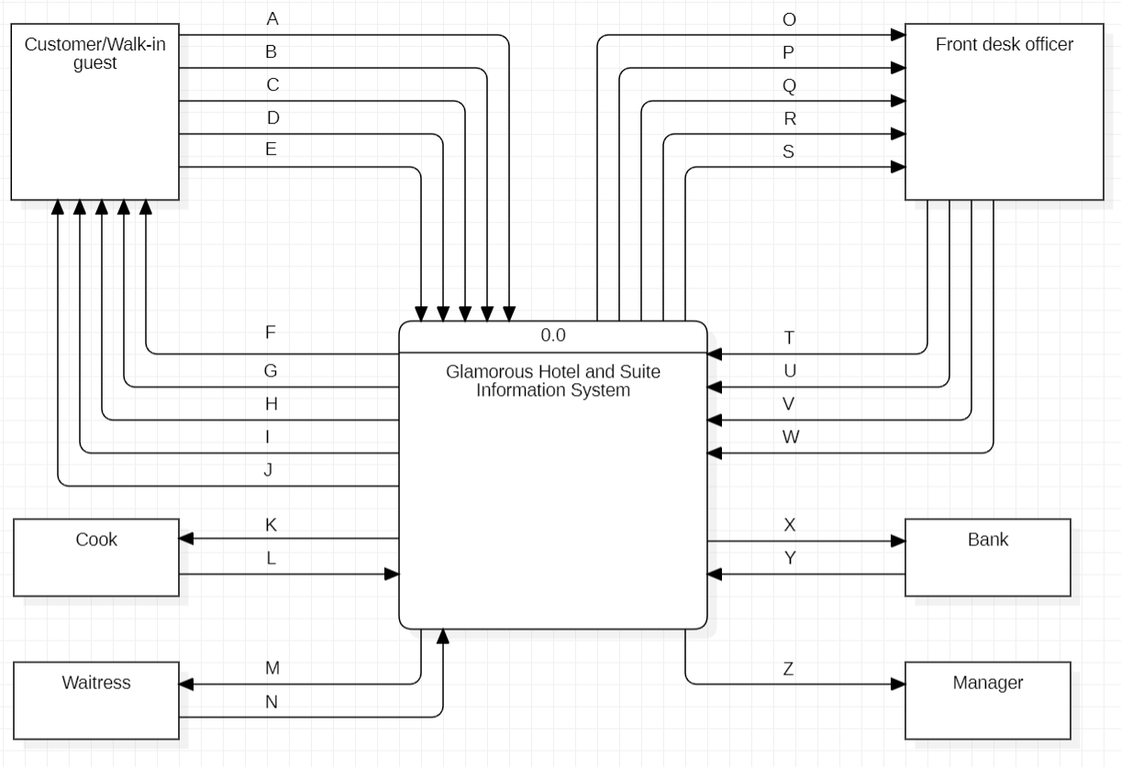

A: Registration information

B: Reservation request

C: Cancellation request

D: Food order request

E: Online/cash payment

F: Payment receipt

G: Registration Feedback

H: Reservation feedback

I: Cancellation feedback

J: Order food feedback

K: Ordered food information

L: Food ready

M: Room number

N: Delivery completed

O: Registration information items

P: Reservation request items

Q: Cancellation request items

R: Food order request items

S: Customer payment information

T: Customer records

U: Confirm room reservation

V: Confirm room availability

W: Confirm food order

X: Withdrawal request

Y: Withdrawal approval

Z: Transaction report

**1.3 Product Perspective**

**Dataflow Context Diagram (DFD Level 1)**

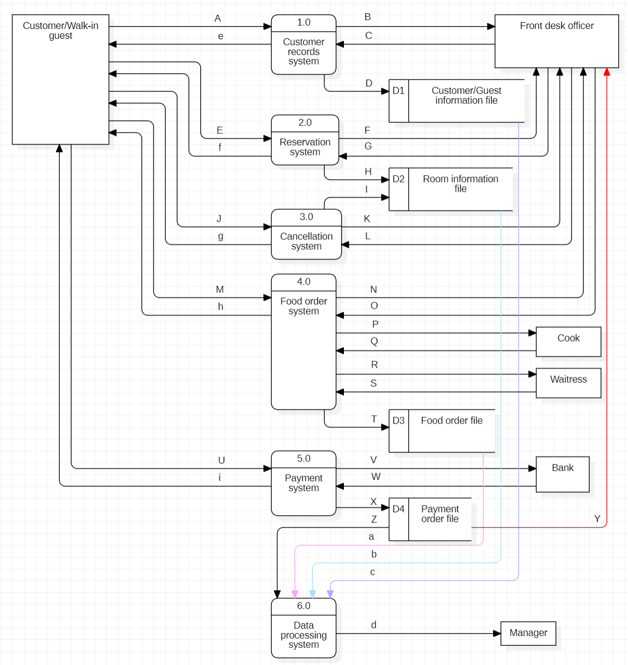

**A:** Registration information

**B:** Registration information items

**C:** Customer records

**D:** Customer records items

**E:** Reservation request

**F:** Reservation request items

**G:** Confirm room reservation

**H:** Room unavailable state

**I:** Room availability state

**J:** Cancellation request

**K:** Cancellation request items

**L:** Confirm room availability

**M:** Food order request

**N:** Food order request items

**O:** Confirm food order

**P:** Ordered food information

**Q:** Food ready

**R:** Room number

**S:** Delivery completed

**T:** Food sales items

**U:** Online/cash payment

**V:** Withdrawal request

**W:** Withdrawal approval

**X:** Payment order items

**Y:** Customer payment information

**Z:** Payment order data

**a:** Food sales data

**b:** Room transaction data

**c:** Customer record data

**d:** Transaction report

**e:** Registration Feedback

**f:** Reservation feedback

**g:** Cancellation feedback

**h:** Order food feedback

**i:** Payment receipt

**1.4 Specific Requirements**

**1.4.1a Functional Requirement - Use Case Diagram**

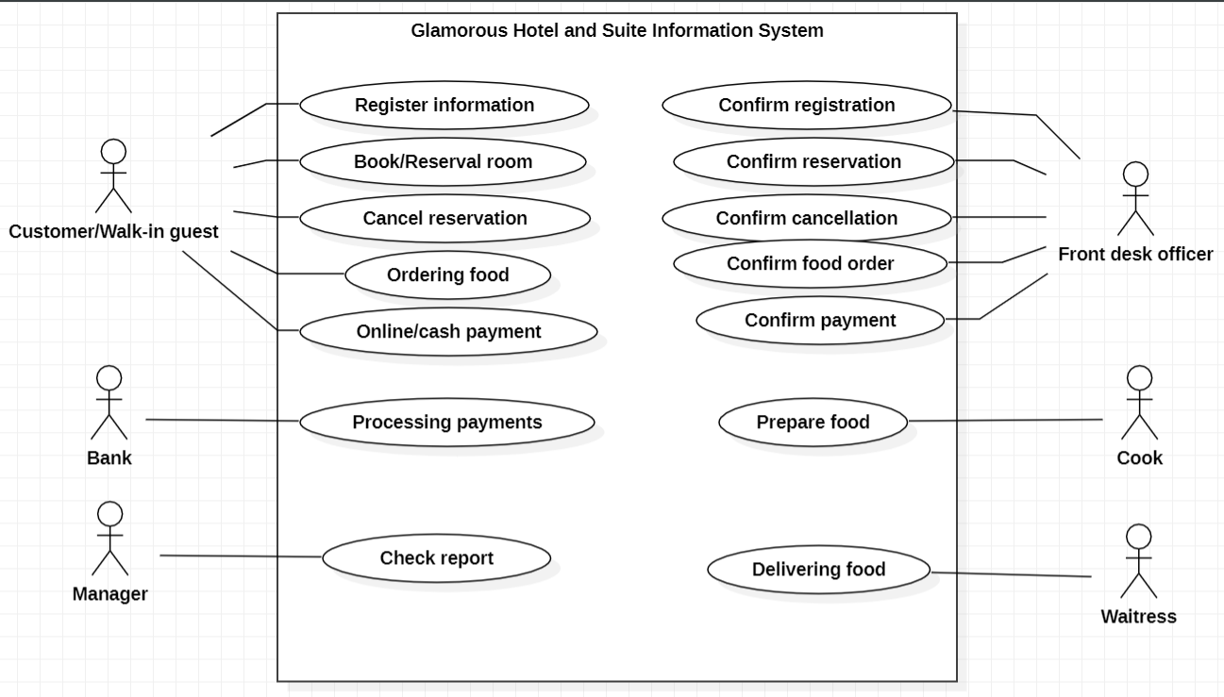

**1.4.1b Functional Requirement - Use Case Documentation**

|  |  |
| --- | --- |
| * **Usecase 1:** Registration information | |
| **Brief description:** | This feature will allow a customer/walk-in guest to register his/her personal information including name, address and phone number. |
| **Rationale:** | The front desk needs to confirm customer information and store it in the information system for booking and other services. In addition, the system will allow customers to fill in their personal information securely and completely, reducing human error and ensuring personal privacy. |
| **Basic flow:** | * Customers require registration * A blank personal information table is displayed * Customer completes information sheet * Customer confirm |
| **Alternative flow:** | The customer cancels the registration and returns to start |
| **Pre-condition:** | The customer logged into the system but did not register |
| **Post-condition:** | Personal information is sent to the hotel system and awaits confirms from the front desk |

|  |  |
| --- | --- |
| * **Usecase 2:** Reserve room | |
| **Brief description:** | This feature allows a customer/guest to take a currently available room from the hotel room list and issue a reservation request to the system. |
| **Rationale:** | Customers can efficiently understand the room information and make choices, reduce the energy and time consumption and the workload of the front desk, improve the selection efficiency. |
| **Basic flow:** | * Customer application for reservation * The system checks that the customer is registered * The system checks that the customer has booked * The system accepts reservation requests * A list of available rooms is displayed * Guest choice room * Customer confirms |
| **Alternative flow:** | The customer cancels or has booked any room |
| **Pre-condition:** | The customer is logged in and registered |
| **Post-condition:** | The room reservation request is sent to the system and is awaiting approval |

|  |  |
| --- | --- |
| * **Usecase 3:** Cancel reservation | |
| **Brief description:** | 'Cancel reservation' This feature will allow a customer/guest to request a reservation online from the system. The customer provides his or her worthy reasons and is recorded by the system for the reception to confirm. |
| **Rationale:** | The system will allow customers to cancel their reservations online, reducing time and effort and providing convenience. In addition, the front desk will confirm the applications in the system one by one, which improves the work efficiency. |
| **Basic flow:** | * The customer requested to cancel the reservation * System detects reservation * System accepts applications * The system displays a blank table * Customer fill out form (worthy reason) * Customer submission * System requirement confirms * Customer confirms |
| **Alternative flow:** | The customer cancels the application and returns to start. |
| **Pre-condition:** | The customer has registered and booked any room. |
| **Post-condition:** | The cancellation request is sent to the hotel system and awaits confirms. |
| * **Usecase 4:** Ordering food | |
| **Brief description:** | This feature will allow a customer/guest to browse a menu online and order food. Food orders will be confirmed and recorded by the system. |
| **Rationale:** | The food order will be sent to the cook after being confirmed by the front desk. In addition, the system will enable customers to order meals online, thereby reducing time and effort and providing convenience, thus increasing hotel revenue. |
| **Basic flow:** | * The customer requested a reservation * System check has been registered * System detects reservation * System accepts applications * System display menu * Customer choice food * Customer submission option * System requirement confirms * Customer confirms |
| **Alternative flow:** | The customer cancels the order and returns to start. |
| **Pre-condition:** | The customer has registered and booked any room. |
| **Post-condition:** | Food orders are sent to the hotel system for confirms. |

|  |  |
| --- | --- |
| * **Usecase 5:** Online payment | |
| **Brief description:** | The 'Online payment' feature will allow a customer/guest to pay for any hotel service online, and the payment record will be recorded and counted by the system. |
| **Rationale:** | The payment system accepts the payment request and needs to apply for withdrawal from the bank to judge whether the payment is successful. In addition, the system will enable customers to pay online, improve the security and stability of payment, and make the payment process efficient and simple. |
| **Basic flow:** | * The customer demands payment for any service provided by the hotel * System check has been registered * System check has been paid * System accepts applications * The payment interface is displayed * Customer choice to pay * The system provides payment details and asks for confirms * Customer pay |
| **Alternative flow:** | Customer cancels or has paid. |
| **Pre-condition:** | Customer requests hotel services but does not pay. |
| **Post-condition:** | The payment order is sent to the hotel system for confirms. |
| * **Usecase 6:** Processing payments | |
| **Brief description:** | 'Processing payments' will allow the bank to process cash requests from the hotel system to determine whether the payment has been made and give feedback. |
| **Rationale:** | The front desk needs to know if the customer is paying the service charge to confirm the service request. In addition, the system stores payment records, so that customers and the front desk can constantly check the payment records, avoid manual recording errors, and protect customers' consumption rights. |
| **Basic flow:** | * Hotel payment system request for cash * Bank acceptance of request * The bank checks customer balances * The bank agreed to the hotel's withdrawal * Banks deduct customer balances * Bank transfer to hotel * The system records withdrawals * Bank confirm |
| **Alternative flow:** | The customer's balance is insufficient and the withdrawal fails. |
| **Pre-condition:** | The customer applied for payment but failed to pay. |
| **Post-condition:** | The customer makes a successful payment and receives a receipt, which is recorded in the system. |
| * **Usecase 7:** Confirm registration | |
| **Brief description:** | The 'Confirm information' feature will allow a front desk officer to process a customer's registration information and give feedback. Correct customer information will be allowed to register and record. |
| **Rationale:** | The front desk needs to process customer information and record it in the system. In addition, the system stores customer records, avoids manual recording errors, protects customer privacy, and improves the work efficiency of the front desk. |
| **Basic flow:** | * System request confirm * The system displays a list of pending orders * Order selection at the front desk * The system displays order details * Order processing at the front desk * Submit feedback at the front desk * System request confirm * Front confirms |
| **Alternative flow:** | Customer information is invalid. Customer is required to fill it in again. |
| **Pre-condition:** | The customer submitted personal information but it was not confirmed. |
| **Post-condition:** | The customer is successfully registered and the customer record is stored in the system. |

|  |  |
| --- | --- |
| * **Usecase 8:** Confirm reservation | |
| **Brief description:** | The 'Confirm reservation' feature will allow a front desk to confirm a customer's reservation request and give feedback. If you agree to make a reservation, the room will be reserved and become unavailable. |
| **Rationale:** | The front desk needs to confirm that the reservation request is valid. In addition, the system allows online booking, reducing the workload of the front desk and improving the work efficiency of the front desk. |
| **Basic flow:** | * System request confirm * The system displays a list of pending orders * Order selection at the front desk * The system displays order details * Check the payment at the front desk * Order processing at the front desk * Submit feedback at the front desk * System request confirm * Front confirms |
| **Alternative flow:** | The room is damaged and not available. |
| **Pre-condition:** | Customer requested reservation and paid. |
| **Post-condition:** | The customer successfully makes a reservation, and the reservation record is stored in the system. |

|  |  |
| --- | --- |
| * **Usecase 9:** Confirm cancellation | |
| **Brief description:** | The Confirm cancellation feature will allow a front desk to review the reasons behind a customer's cancellation request and give feedback, and successful cancellations will be made available. |
| **Rationale:** | The system needs the front desk to process the cancellation request in time to update the hotel cancellation information. In addition, the system allows full online service and communication, improving the efficiency of the front desk and reducing errors. |
| **Basic flow:** | * System request confirm * The system displays pending cancel orders list * Order selection at the front desk * The system displays order details * Order processing at the front desk * Submit feedback at the front desk * System request confirm * Front confirms |
| **Alternative flow:** | The front desk cancels processing the order and returns to start |
| **Pre-condition:** | The customer submitted a cancellation order, but it was not confirmed. |
| **Post-condition:** | The customer successfully cancelled the reservation and the room became available. |

|  |  |
| --- | --- |
| * **Usecase 10:** Confirm food order | |
| **Brief description:** | The "Confirm food order" feature will allow a front desk to confirm that a customer's food order request is valid and give feedback. |
| **Rationale:** | The system needs to be confirmed by the front desk before it can tell cook to start preparing the food. In addition, the system assists the front desk by providing customer transaction records and reducing the workload of the front desk, thus reducing the number of errors. |
| **Basic flow:** | * System request confirm * The system displays pending food orders list * Order selection at the front desk * The system displays order details * Check the payment at the front desk * Order processing at the front desk * Submit feedback at the front desk * System request confirm * Front confirms |
| **Alternative flow:** | The front desk officer unconfirms and returns to start. |
| **Pre-condition:** | The customer has ordered food and paid for it. |
| **Post-condition:** | The customer successfully ordered food and recorded it in the system. |

|  |  |
| --- | --- |
| * **Usecase 11:** Confirm payments | |
| **Brief description:** | The "Confirm payments" feature will allow a receptionist to check the payment record to see if the customer has made a payment. |
| **Rationale:** | The system needs the reception to confirm the successful payment before providing the required services to customers. In addition, the system stores payment records for the foreground to query, thereby reducing workflow and improving work efficiency. |
| **Basic flow:** | * The front desk asks for payment records * System acceptance requirement * The customer list is displayed * The front desk selects the target customer * The system displays object payment records * Reception confirms payment/non-payment * Front desk return start |
| **Alternative flow:** | The foreground cancels the query and returns to start |
| **Pre-condition:** | Customer requests any service and is to be confirmed |
| **Post-condition:** | The front desk confirms the payment and starts the next process |

|  |  |
| --- | --- |
| * **Usecase 12:** Prepare food | |
| **Brief description:** | The "Prepare food" feature will allow a cook to take a pending food order through the system and report that the food is ready when completed, and the food order is recorded in the system. |
| **Rationale:** | The system requires cook to let the waitress transport the food to the customer after completing the order. In addition, the system stores food order records and statistics of the best food of the day, providing effective information for managers to change the food menu. |
| **Basic flow:** | * cook asks for food orders * System accept request * The list of pending orders is displayed * cook selects food order processing * cook notifies the system that the order is complete * System acceptance notification * System requirement confirms * cook confirms |
| **Alternative flow:** | The front desk officer unconfirms and returns to start. |
| **Pre-condition:** | The customer has ordered food and paid for it. |
| **Post-condition:** | The customer successfully ordered food and recorded it in the system. |

|  |  |
| --- | --- |
| * **Usecase 13:** Delivering food | |
| **Brief description:** | The Delivering food feature will allow the system to notify a waitress to come to the kitchen to pick up a delivery of food to be delivered to the door of the target guest room. |
| **Rationale:** | Delivery of food to the door of the guest room is convenient for customers to eat and ensure customer satisfaction. In addition, online notification simplifies the working process and improves the efficiency of the waitress. |
| **Basic flow:** | * The waitress asked for the food to be delivered * The system accepts the request * The system displays the order information * The waiter reports that the order has been completed * System requirements validation * The waiter confirms |
| **Alternative flow:** | The order information is wrong again, waitress can’t complete. |
| **Pre-condition:** | Any waitress is available and food needs to be delivered |
| **Post-condition:** | Food transportation completed, waiting for customer acceptance |

|  |  |
| --- | --- |
| * **Usecase 14:** Check report | |
| **Brief description:** | This "Check report" feature will allow the system to process any transaction data of the hotel and generate an accurate and timely transaction report of the company to the manager to assist in the management of the hotel. |
| **Rationale:** | The hotel's raw transaction data needs to be accurately and timely processed into a company transaction report so that managers can easily understand the company transactions. In addition, the report generated by the system is more objective and real-time, which helps managers make more valuable decisions. |
| **Basic flow:** | * The manager asked for the transaction report * System check identity * The system displays the transaction report * System request confirm * Manager confirm * Manager returns to statrt |
| **Alternative flow:** | The manager dropped the transaction report and returns to start. |
| **Pre-condition:** | The manager logs into the system and needs the report. |
| **Post-condition:** | The manager got the trading report |

**1.4.2 Non Functional Requirement**

After analyzing the problems and requirements inherent in Glamorous Hotel and Suite, an important non-functional requirement in supporting hotel business functions in future computerized information systems will be reliability. The system must be extremely reliable and available throughout the day to ensure that customers are able to register, make reservations, book meals, and other hotel services 24 hours a day without experiencing problems such as system crashes when the system cannot respond to customer requests. In addition, the system should do what it says it will, for example, a customer's reservation request should be properly presented by the system to the front desk for confirmation and not lost or passed to someone else.

Security is also inherent in the system. The system will use measures such as firewalls, encrypting information and setting access keys to protect important data from hackers or abnormal damage.

Another important non-functional requirement of the system is high performance. Systems must have fast response, low latency, and multithreading to ensure that the system can process large amounts of data and instructions in real time and ensure effectiveness.

The system should have good availability. The system should be easy for hotel staff and customers to use, with clear instructions and an easy-to-understand interface.

The system should also be compatible, meaning that it can be used across different systems and equipment to make it easier for customers and staff to use.

Maintainability is also an important non-functional requirement of the system. Systems should be easy to maintain and have a clear modular design that allows data or modules to be easily and quickly checked or updated without affecting the proper functioning of the overall system, thereby improving the efficiency and reducing maintenance costs of the system.

In addition, accuracy is also an important non-functional requirement of the system. The system shall ensure the accuracy of data, especially user input data. For example, the system can provide input examples and explicit instructions to keep data entry at a high accuracy. Meanwhile, data processing can also be regulated by software. In order to ensure the accuracy of data with higher efficiency.

Finally, the system is scalable. The system should allow for expansion, such as adding new mission modules or updating existing modules, in order to accommodate possible future growth of the hotel, including more complex menus and more hotel services.

1. **Technical Design**
   1. **Data Model**

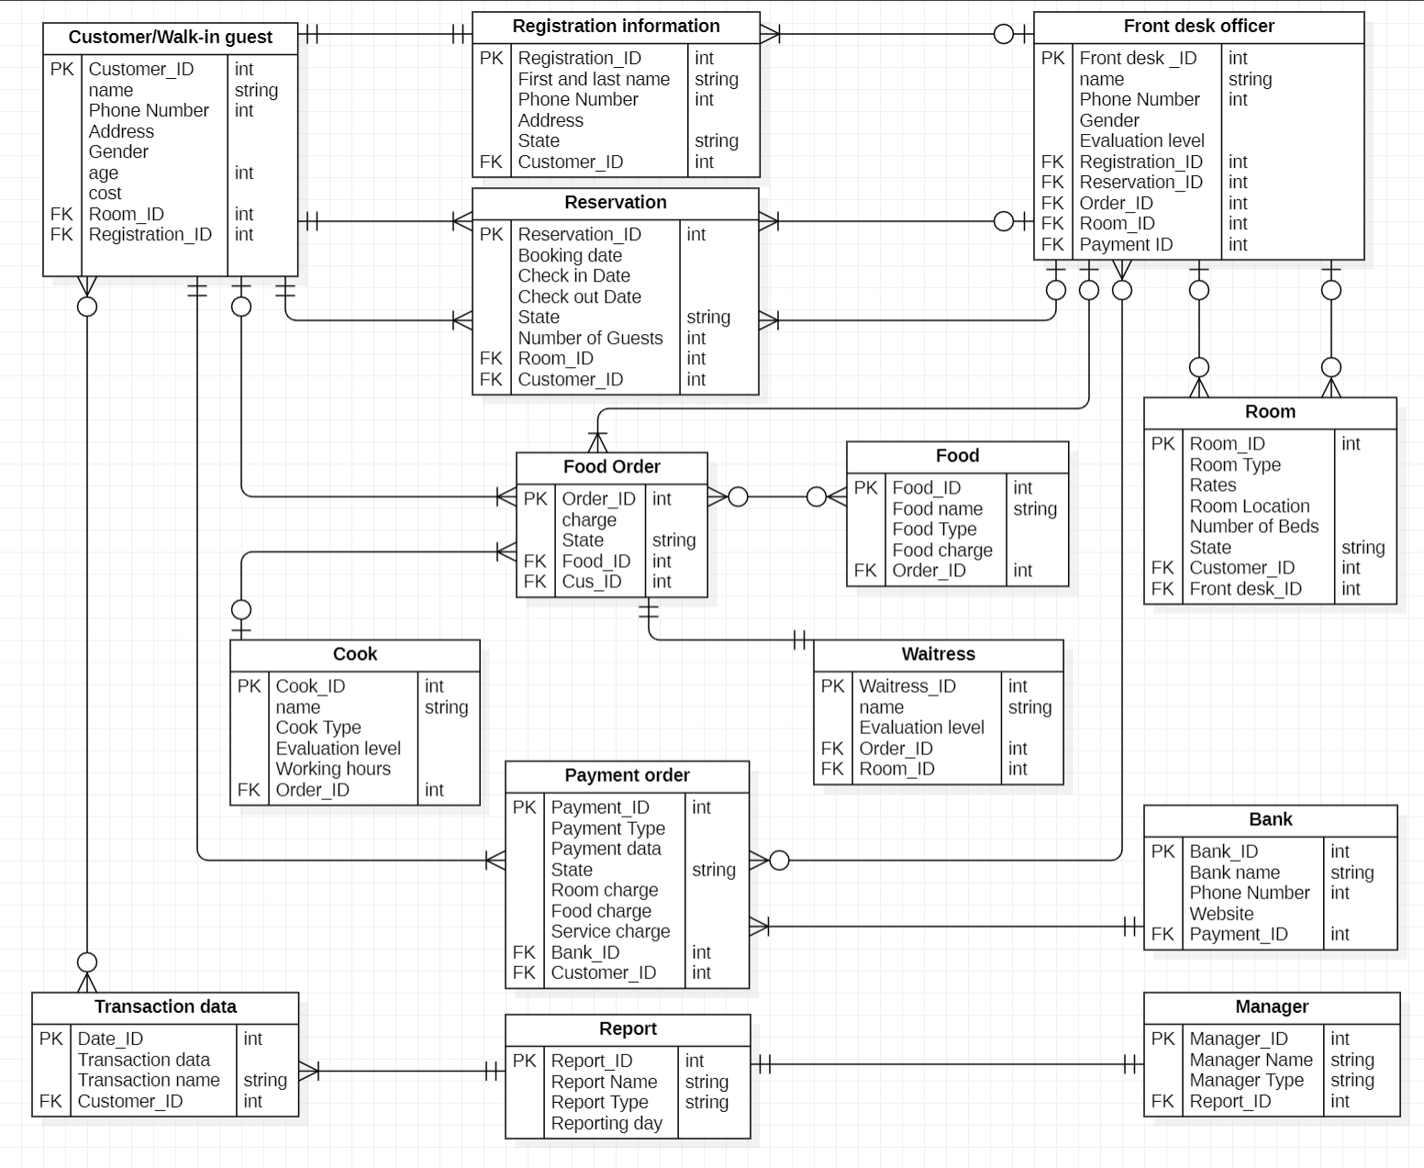

* 1. **Sequence Diagrams**

**Registration information**

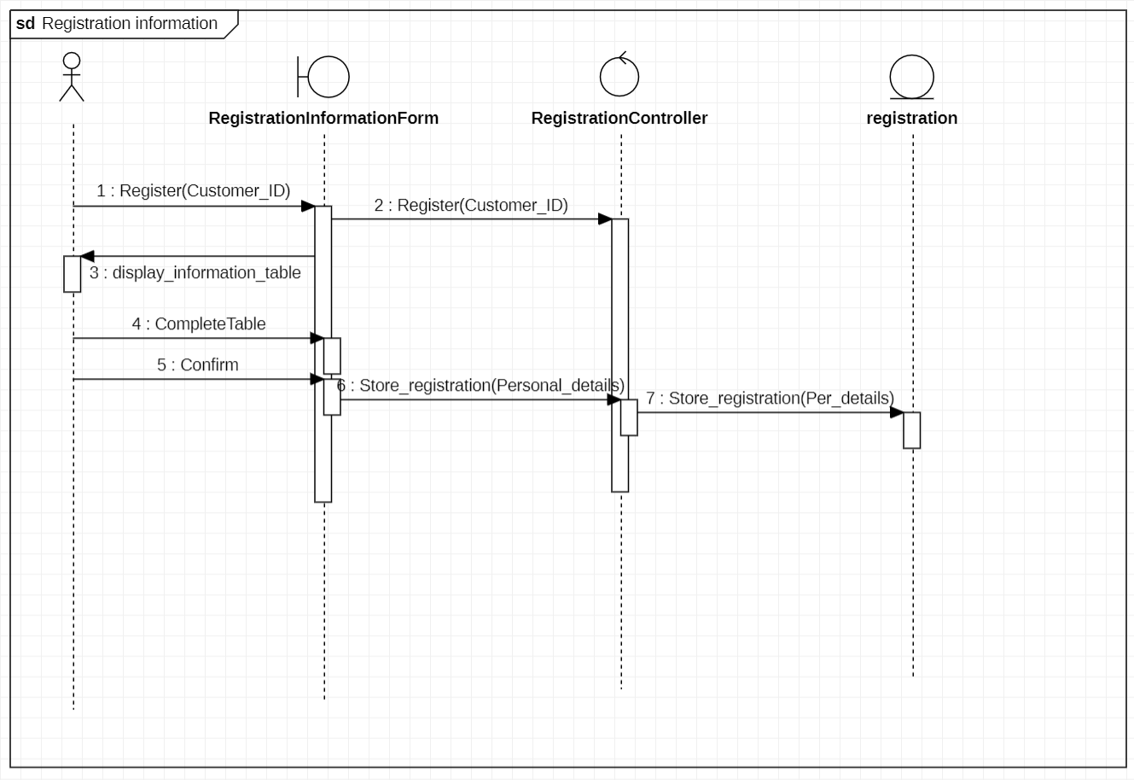

**Reserve room**

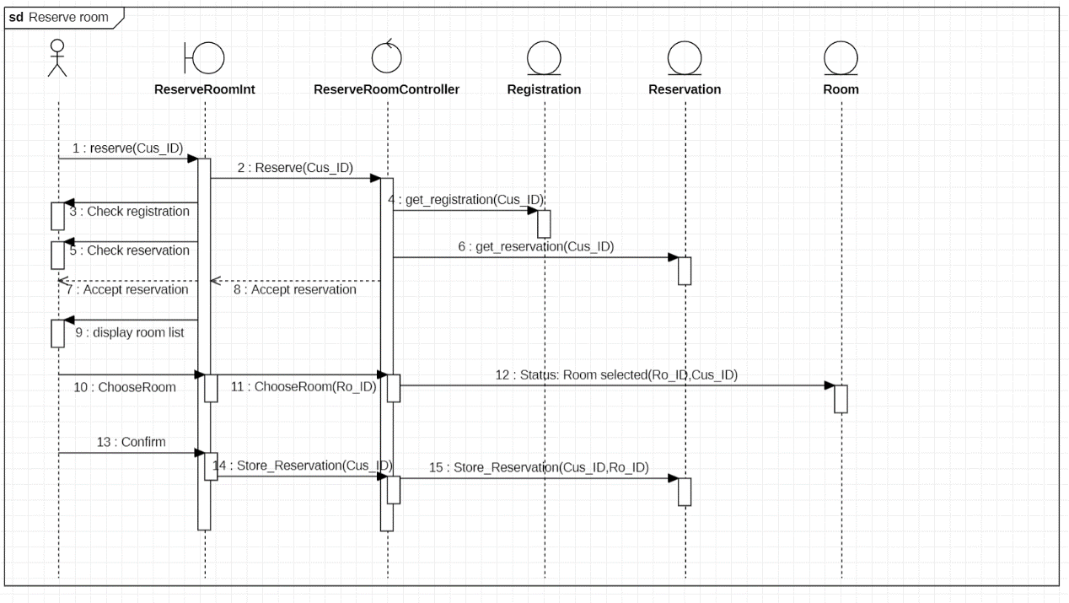

**Cancel reservation**

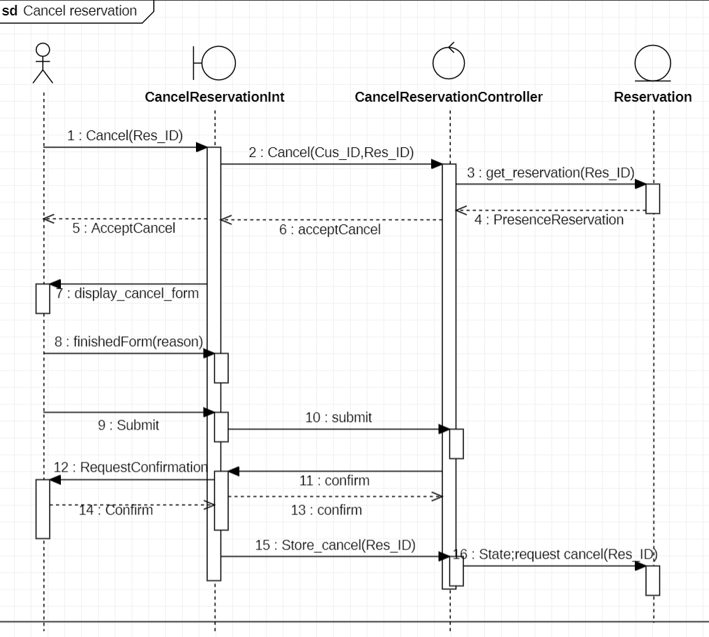

**Ordering food**

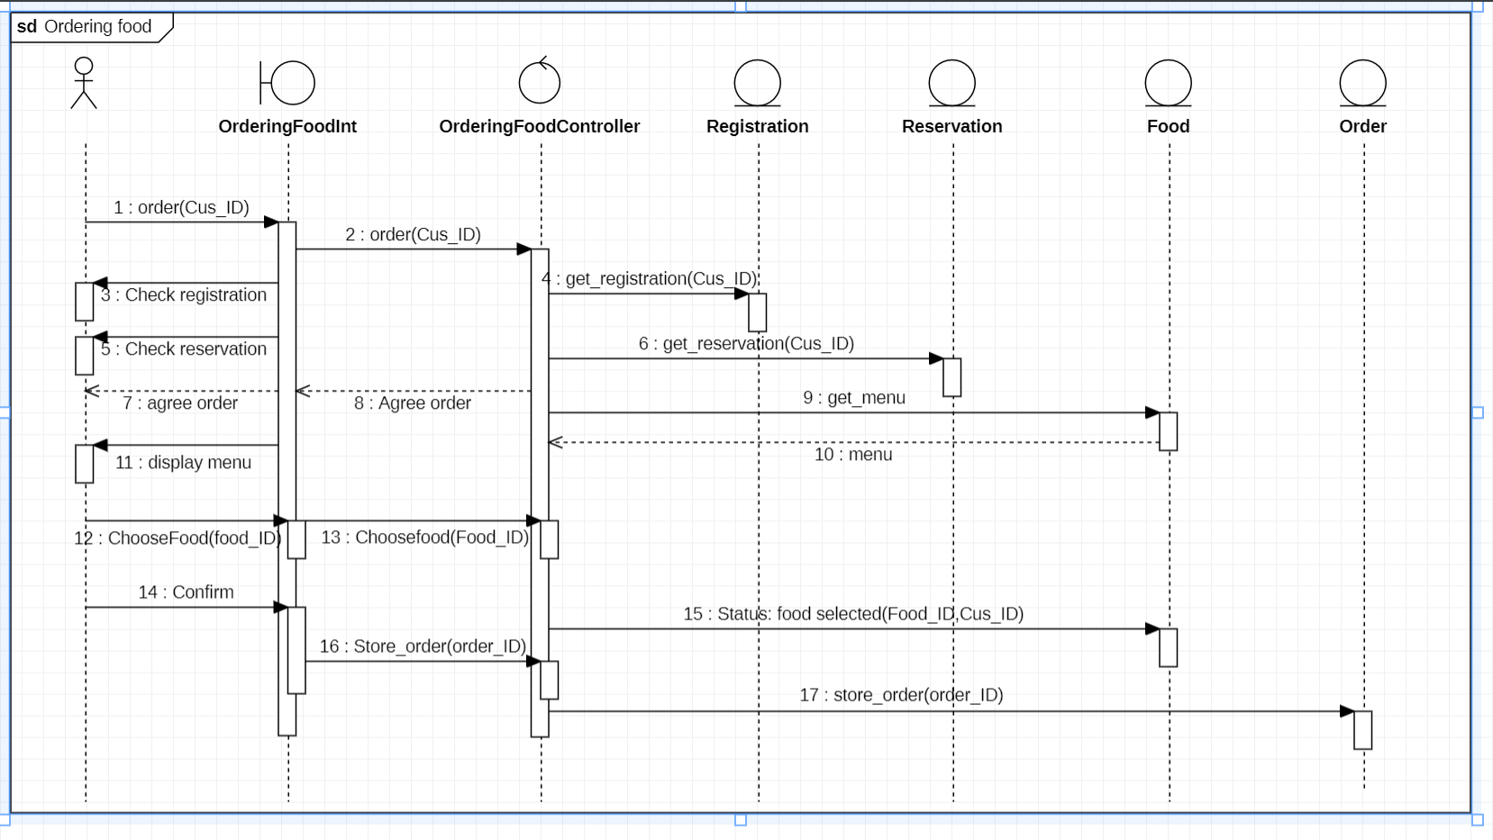

**Online payment**

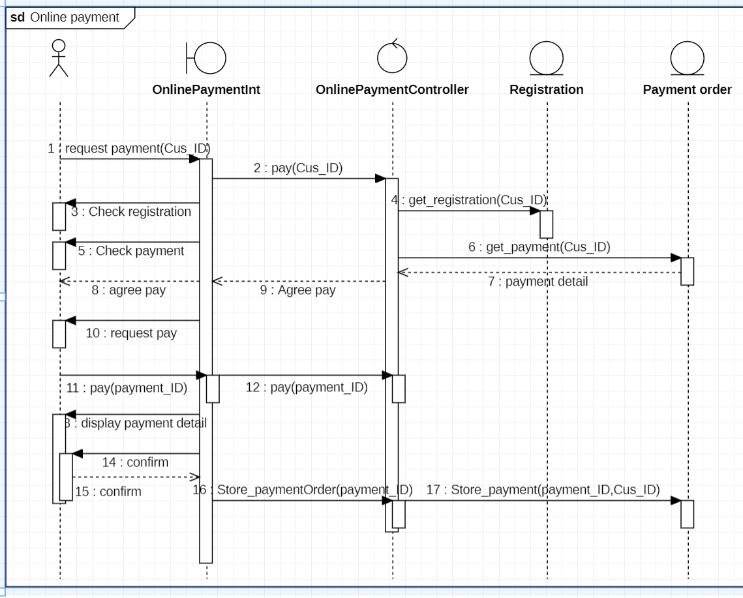

**Processing payments**

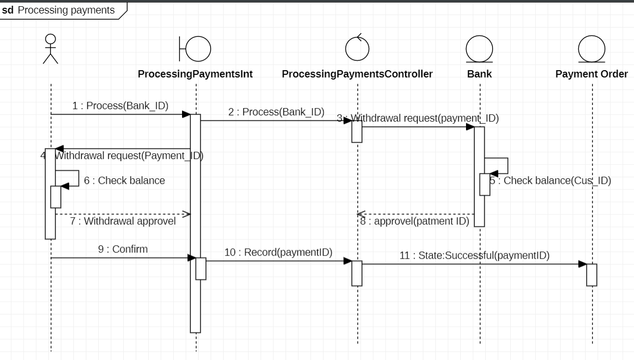

**Confirm registration**

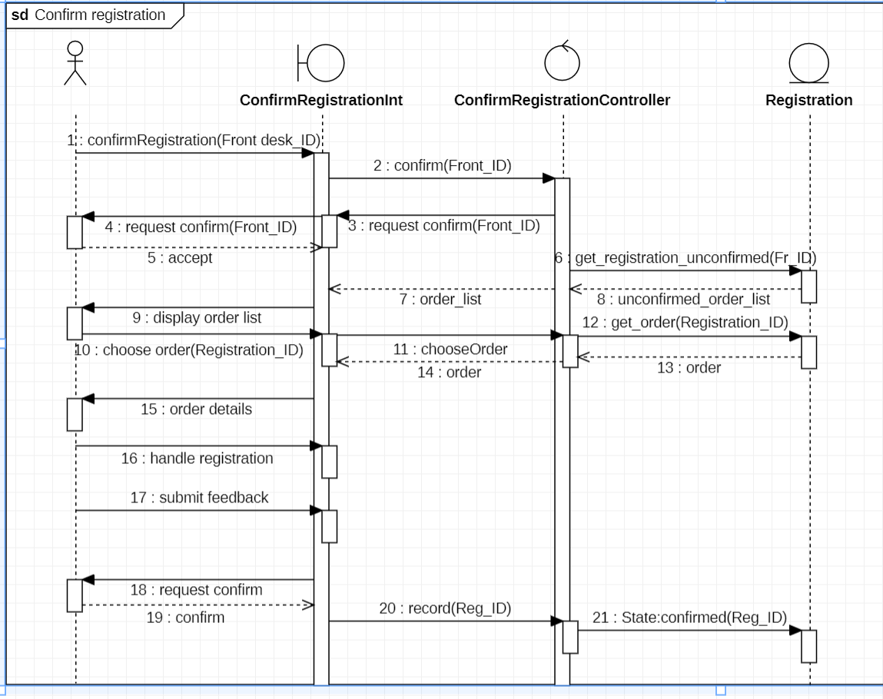

**Confirm reservation**

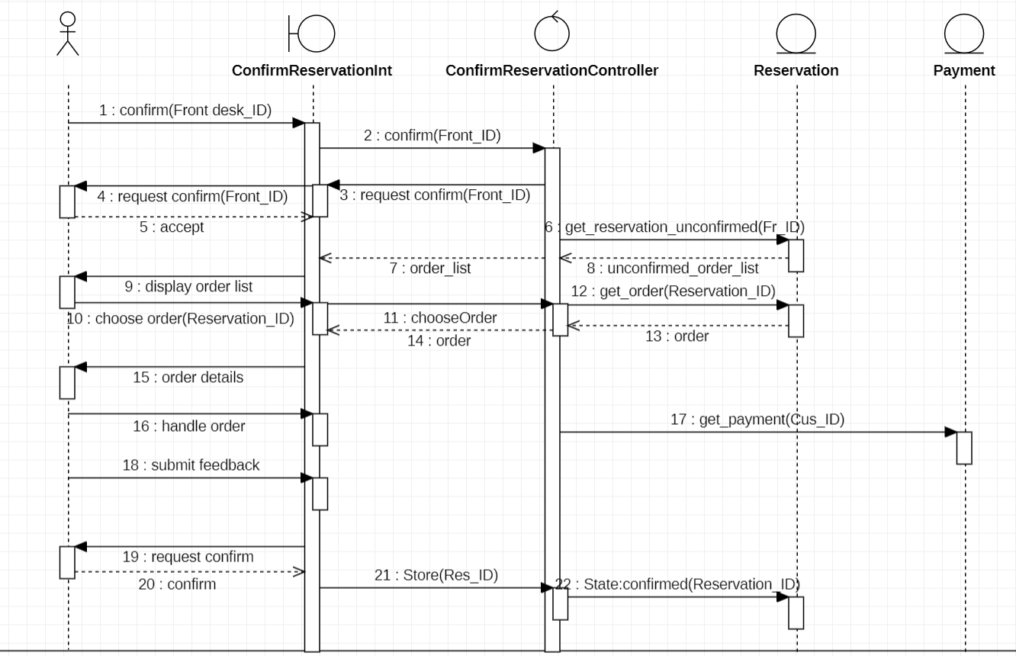

**Confirm cancellation**

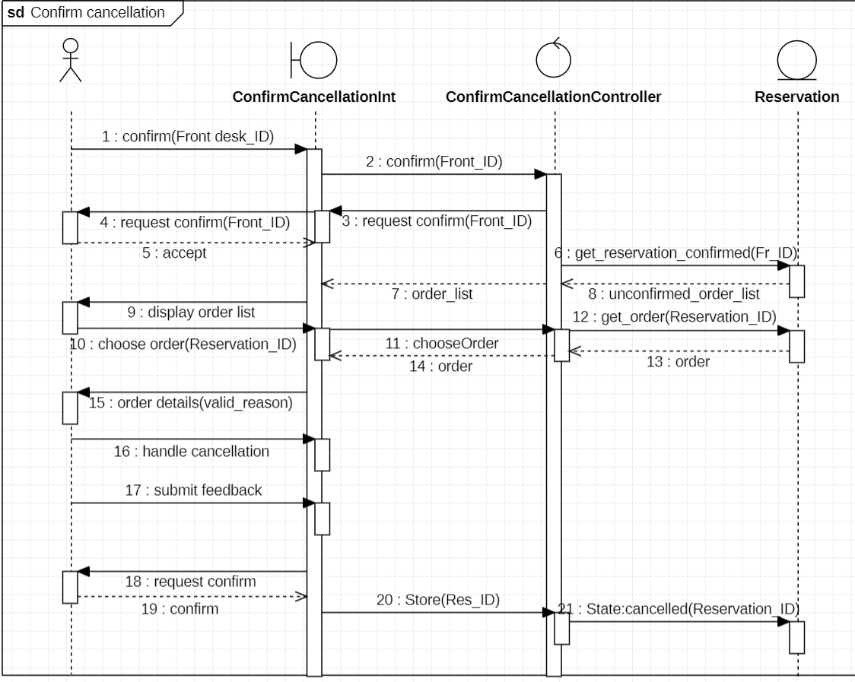

**Confirm food order**

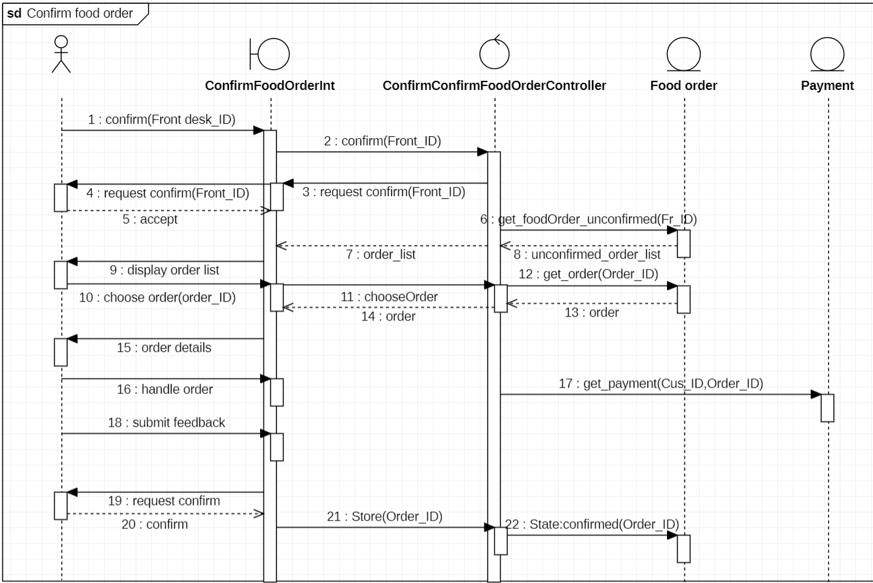

**Confirm payments**

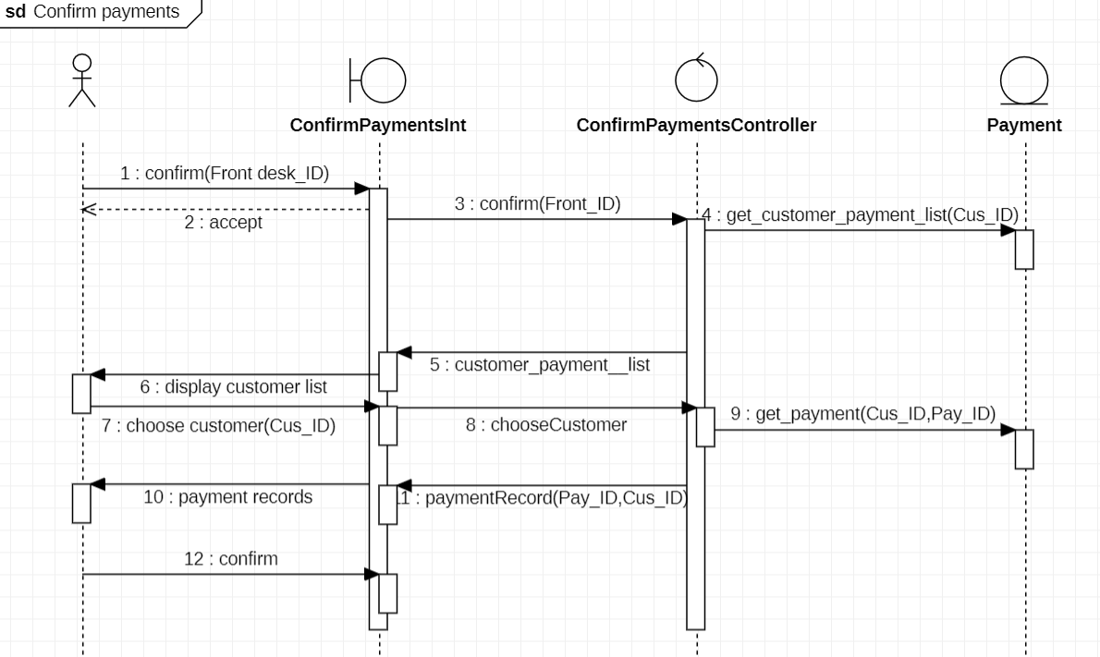

**Prepare food**

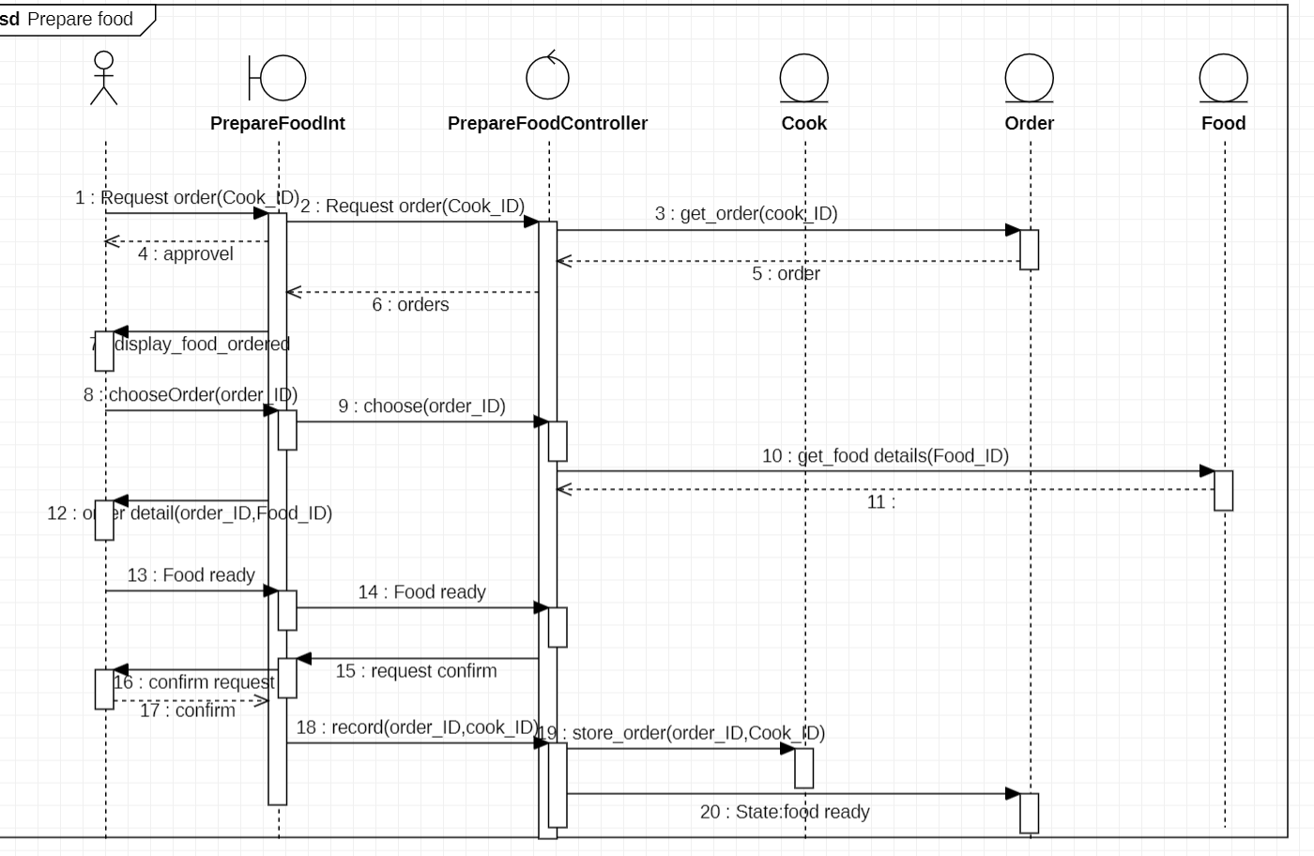

**Delivering food**

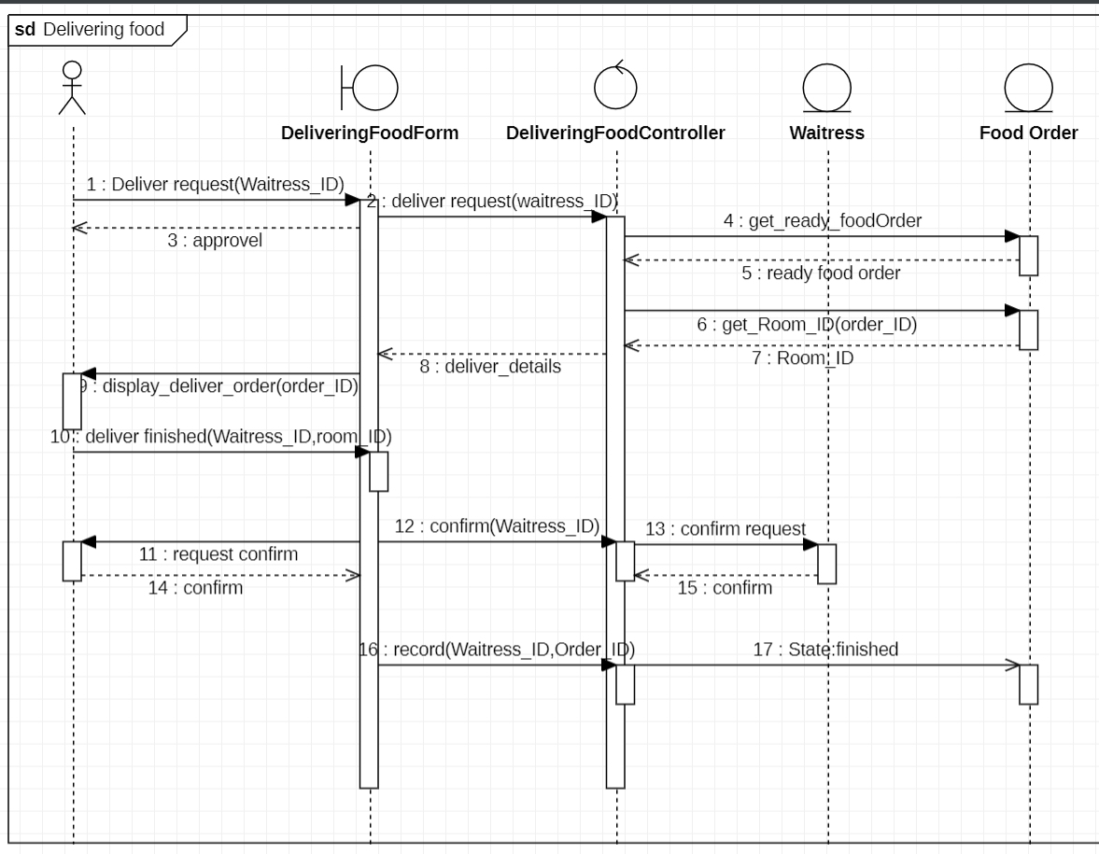

**Check report**

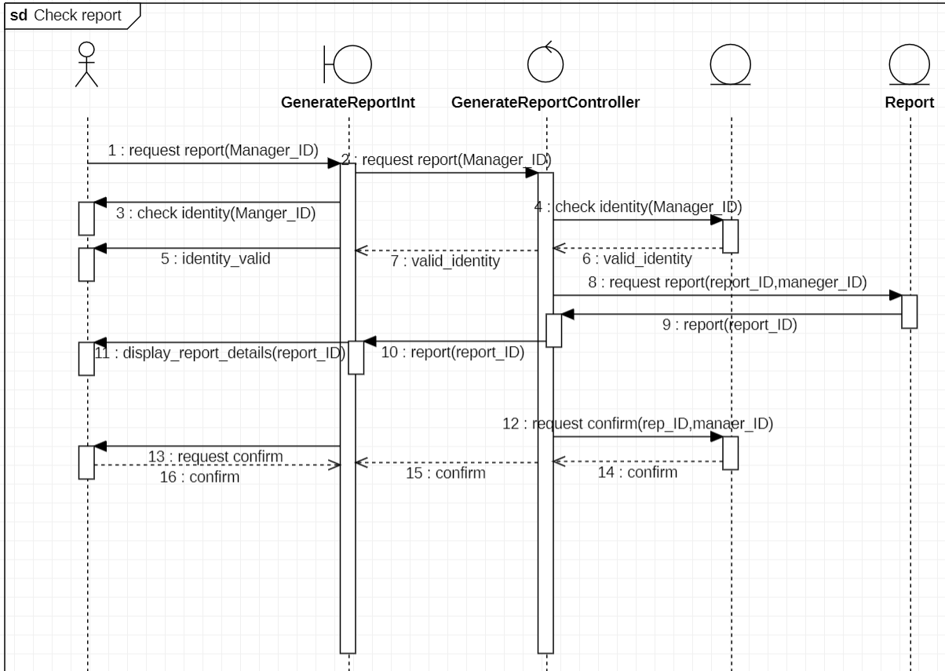

* 1. **Analyse the Data:**

With the implementation of computerized information systems, managers of Glamorous Hotel and Suite will have access to data on multiple transactions that can help monitor and improve hotel operations. The data model contains different information stored in the system.

Firstly, customer records including personal information such as names, addresses, and telephone numbers can be stored in the system. This information can help the manager intuitively track customer behavior. For example, when the manager accesses any customer information, the system will display other transaction records and details of the customer. This will help the manager clearly understand the hotel customer information.

Secondly, the system will provide timely updates on the customer's booking of rooms and cancellations, which will allow the manager to track trends in hotel occupancy. This information helps managers make more valuable strategic decisions, such as increasing the number of employees during peak periods and adjusting hotel rates and hotel room types based on high and low demand.

Third, daily ordering and food ordered the most times of the day will help managers optimize the hotel's ordering system. Hotel managers can use this data to determine which foods are more popular, thus adjusting food prices, as well as optimizing food menus to reduce food waste and control costs.

Fourth, online payment for any services that the company needs will make revenue from different kinds of hotels easier to track and manage. Managers who want to view hotel revenue will become more efficient and accurate, because the system will be classified by customer - ID, payment type, service type and payment date, allowing managers to enter keywords to quickly find the required payment order.

Finally, accurate and timely reporting of transactions by the company will provide the manager with an overview of the hotel's trading status and help the manager judge areas of inefficiency that need improvement. For example, the system will automatically generate a daily transaction report based on the hotel transaction data, showing all the transactions of the hotel, so that the manager can make targeted strategic decisions for each area of the report to improve the overall attractiveness of the hotel.

In short, the system helps hotel managers better understand and manage hotel affairs through good data management, which greatly improves work efficiency.

**Conclusion**

In summary, the system can effectively help the Hotel manager to manage various transaction records of Glamorous Hotel and Suite, simplify the workflow of Glamorous Hotel and Suite, and thus improve the operation efficiency of the hotel. The workload of various staff in the hotel will be reduced, and everyone's work process will be streamlined, so they can focus on more useful work and improve work efficiency. In addition, customers will get more convenient, efficient and modern services from the computerized information system, which can better meet their consumer needs and stimulate consumer desire.

**References**

[1] Ping J. Research on the information System architecture design framework and reference resources of American Army[C]//The International Society for Applied Computing. Proceedings of 2021 3rd International Conference on Advanced Information Science and System (AISS 2021).ACM,2021:254-258.DOI:10.26914/c.cnkihy.2021.052225.

[2] He T, Li Z. A Model and Method of Information System Security Risk Assessment based on MITRE ATT&CK[C]//The International Society for Applied Computing (ISAC),The Technical Institute for Engineers (TIE.).Proceedings of 2021 2nd International Conference on Electronics, Communications and Information Technology (CECIT 2021).IEEE COMPUTER SOCIETY,2021:117-122.DOI:10.26914/c.cnkihy.2021.065399.

[3] Zhang Xianyu, Ming Xinguo. An implementation for Smart Manufacturing Information System (SMIS) from an industrial practice survey[J]. Computers & Industrial Engineering,2020(prepublish).